Chapter 14, Problem 65.

A highpass filter is shown in Fig. 14.92. Show that the transfer function is

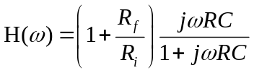

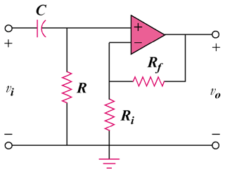

Figure 14.92
For Prob. 14.65.

